#1. MARKING THE ATTCHMENT POINTS ON THE WALL:
- Thoroughly review the supplied approved shop drawings and familiarize yourself with them
- Read through all instructions prior to beginning the installation of the canopy or any bolts
- Determine the height to the bottom of the canopy by the approved shop drawings
- Mark the bottom of the canopy
- Mark the centerline of the canopy according to the features of the building & the approved drawings
- Transfer this centerline up to the height of the hanger rod centerline at the top of the rods
- Mark the centerline of the upper thru-bolts according to the drawings, working from the centerline of the canopy out to the hanger locations according to the drawings
- Drill the holes in the wall according to the approved canopy shop drawings for the upper hangers
- Drill holes in the back of the canopy gutter in accordance with the shop drawings
- Mark & drill the wall according to the holes that you drilled in the back of the gutter or go to the next steps
- Hoist the canopy up to the wall with the back level mark the hole locations you just drilled out through the back of the canopy gutter
- Safely lower the canopy down then drill all holes in the building for the canopy back gutter
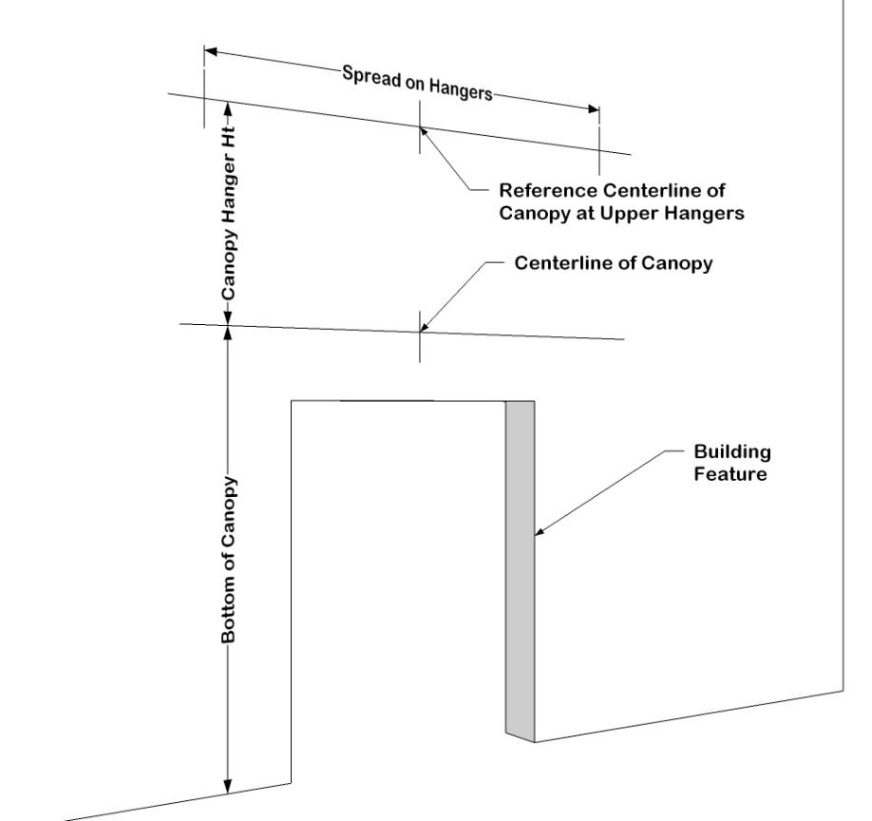
#2. ATTACHING THE CANOPY FRAME AND HANGERS TO THE WALL:
- Seal all wall penetrations; seal behind the large washer or escutcheon plates and any collars
- Secure all upper hanger bracket bolt by securely fastening the thru-bolts to the wall
- Secure all lower connections in the same manner
- Verify the back of the canopy is level
- Level the front of the canopy by twisting the hanger rod to the left or the right
- Adjust the front clevis brackets inside the front gutter to match the same as the upper hanger locations
- Secure the front clevis brackets as shown on the approved drawings, clamp to the front of the front gutter, and protect the finish of the front gutter with a scrap piece of cardboard or other material
- Verify the level of the front gutter again
- Determine which side the water is to drain and slightly tilt the front gutter of the canopy in that direction using the hanger rod by twisting it left or right (this should NOT be a noticeable slope)

#3. INSTALLING THE DECKING:

- Add a small continuous bead of sealant to the inside upper top lip of the gutter between it and the deck pans
- Both the 1st pan and the last pan seam should be the same distance from the inside edge of the gutter, which may require each of these pans to be ripped down along the length, paying attention to which lip is being cut off as they need to join together with the adjacent pan; Add a screw mid-span along the side gutter
- Load the pans from the top of the canopy, interlock the lips and secure according to the drawings
- Clamp each pan together with the adjacent pan when securing to the gutter with the screws shown in the drawings; Be careful not to miss the lip of the gutter when securing the pans
- Add gutter straps to the front gutter fascia as shown on the approved drawings
- Flash or seal the top of the gutter at the building with sealant
#4. WATER DRAINAGE:
- Drill a 2 5/16” diameter hole in the gutter fascia at the desired drain location
- Add either a downspout drain stub or the scupper drain
- Caulk the drain stub, secure with rivets and add the required downspouts, elbows, and straps at desired locations

